East Midlands Synod
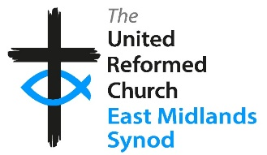
Small Mission Fund Application Form
- Name of Church, Area or Pastorate:
- Project Name:
- Please describe your project, including its aim and activities.
Please include details of any partners.
- How will this project help you to share the Good News about Jesus?
- What difference will this project make to your Church, Area or Pastorate?
- Who will be responsible for managing your project?
- How many team members will be involved in the project and what roles are required?
- Have you carried out a risk assessment, identified any potential risks and put mitigation in place?
- What is the total cost of the project?
- How much are you requesting?
(Normally up to 50% of a total project cost, with a maximum amount of £2,000).
- Where will the other funding come from?
- Contact Details. Please include your name, telephone number and email address:

Signed by: ……………………….………………………………………… Church/Area Secretary (*or other as appropriate)
Signed by: ……………………….………………………………………… Church/Area Treasurer (*or other as appropriate)
Dated: ………………………………………………………………………….

To make a claim on this fund, please complete the application form and send with a copy of the project budget to the Synod Administrator at admin@urc5.org.uk

